<html>
<head>
<title>dnyanganga junior college </title>
<meta name="author" content="physical tag">
<style>
h1{color:black;border:dotted}
p{color:blue;font-size:15px}
B{TEXT DECORATION:underline;font-size:15px}
body{background-color:pink}
</style>
</head>
<body>
<h1 align="center">Dnyanganga juniour college</h>
<p>the foundation of Junior College having Science and Commerce streams is laid in 2001.
We at Dnyanganga Junior College are committed to offer our students Indian ethos through the 3
R’s of research, rationalize and reflect. The curriculum is designed to help each student to
reach his/her full potential<br><br>by providing a wide general education, encouraging a community spirit
and sense of responsibility. Our Jr.College aims at helping the child to develop every facet of
his/her personality. Physical , intellectual, emotional and spiritual<BR><br><br></p> <B> Our efforts are directed
at preparing the students to be disciplined, fearless, curious and well-informed human beings in
a rapidly changing world .The students at Dnyanganga Junior College at the end of their educational
journey will emerge to be both inquirers & thinkers, qualities of a global citizen.</B><BR><BR>
<I>100% RESLUT EVREY YEAR</I><br><br>
<U>Transferring dreams into reality by developing an individual’s potentials through spread
of knowledge and wisdom in an intelligent environment</U><br>
<img src="C:\Users\IT DJC COMP 21\Desktop\VAISHNAVI.B\Principal-Mam.jpg" height="300" width="300">
<a href="page2.html">next</a>
</body>
</html>
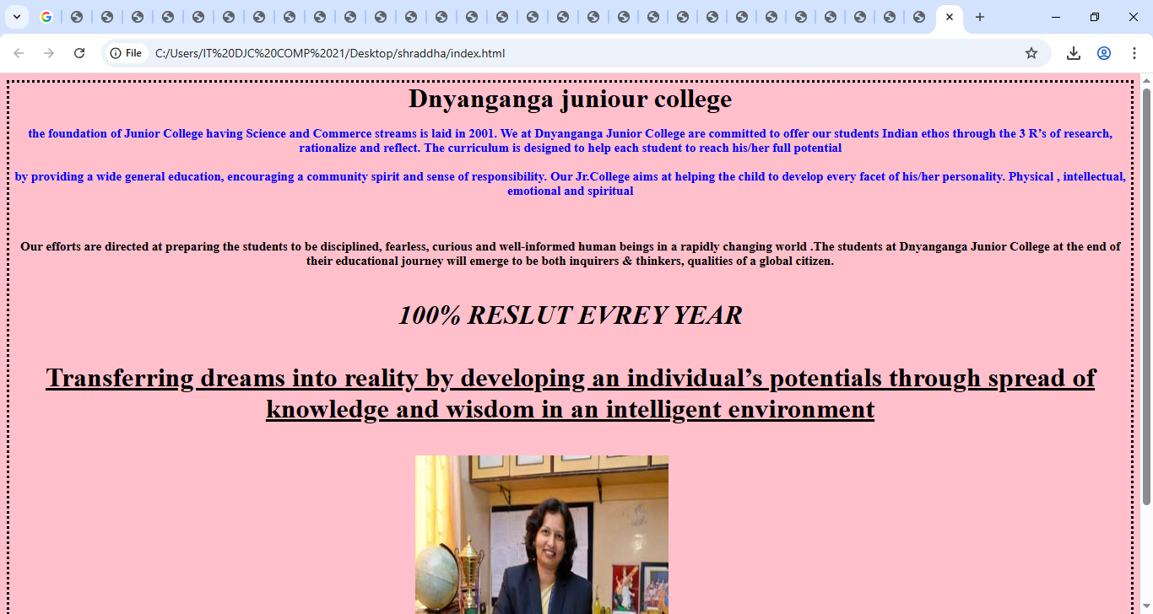

<html>
<head><title>Enrollment form</title>
<meta name ="author"context="form"charest="UTF-8">
<style>
h1{border:dotted}
body{background-color:pink}
</style>
</head>
<body>
<h1 align="center">Enrollment form </h1
<form>
Name<input type="text"name="n1"><br>
<br>
E-mail<input type="e-mail"name="e1"><br><br>
PHONE NUMBER:<INPUT TEXT "TEL"><BR><BR>
<input type="button"value="submit">
</form>
</body>
</html>

